**Understanding uptake of COVID-19 vaccinations amongst children and young people – a meta-analysis of replicated prospective cohort studies within each nation.**

Lead Analysts

**Wales:** Sarah Aldridge

**Northern Ireland:** Siobhán Murphy

**Scotland:**  Tristan Millington

**England:**  Mark Joy

Version History

|  |  |  |  |
| --- | --- | --- | --- |
| **Version** | **Last edited** | **Initials** | **Comment** |
| 0.1 | 2022-01-24 | AA, SB, RO | Initial draft. |
| 0.2 | 2022-02-07 | EL, JB, JQ, RA, TJ, SM | Input ahead of planning meeting 2022-02-08. |
| 0.3 | 2022-02-12 | IR | Added the members of the Scotland group and provided comments on the current version |
| 1.0 | 2022-02-24 |  | Version 1 of the document confirmed |
| 1.1 | 2022-04-11 |  | PPI section details were added, and following multiple co-author reviews and addition, version 1.1 confirmed |
| 2.0 | 2022-06-17 | SA, AA, FT, RO, SB | Elements of the household SAP merged with this to include the role of household vaccination status in meta-analysis. |

Lay Summary

This study will explore how many children aged 5-17 across the United Kingdom were vaccinated up until 31st May 2022. We will also measure the changes in the total number of vaccinated children across the overall group of 5-17 years old with any change in vaccination policy. As well as any differences in vaccination for each age group, either 5-11, 12-15 or 16-17. The study will also explore the impact vaccination status within the rest of the child's household may have on the child's vaccination status.

The research will be completed by searching electronic healthcare record (EHR) data sources available to researchers across the four nations of the United Kingdom. They will report the vaccination uptake for the 5-11, 12-15 and the 16-17 age groups, along with complementary information for their household.

Aim and research questions

The study aims to analyse COVID-19 vaccination uptake amongst children and young people (CYP) across the UK:

**RQ1:** Foreach of the following age groups; 5-11, 12-15, 16-17, what has been the rate of uptake for the first and second dose under the primary schedule, as well as for booster doses?

**RQ2:** How are socio-demographics and clinical characteristics associated with the uptake of each dose? How do these associations vary by age group?

# Study design

A prospective observational cohort study of CYP eligible for vaccination. Descriptive and survival analyses will be conducted on observational e-cohorts within each nation, with results pooled using a meta-analysis approach.

The study period is from 7th July 2021 to 31st May 2022. Within this window, individuals will be followed up based on when JCVI recommended to start vaccinating each age range:

* 16-17 yo: 4th August 2021
* 12-15 yo: 14th September 2021
* 5-11 yo: 15th February 2022

Eligibility for uptake of second and booster doses will start from the following amount of time having passed from the previous dose:

* Second dose: Day 57 from first dose
* Booster: Day 91 from second dose

Additionally, individuals will also be considered as ineligible for the 4-week period (28 days) from which they test positive for COVID-19 infection.

These intervals are based on JCVI guidance that for CYP described as "increased risk", an 8-week interval between 1st and 2nd dose was recommended, while the remainder were advised a 12-week interval. The interval between 2nd dose and the booster is a minimum of 91 days. JCVI also recommends that the minimum interval to receive their COVID-19 vaccination after COVID-19 infection is 4-weeks from the onset of symptoms.

# Data sources

* Vaccination data: Name, date of administration of COVID-19 vaccines, and any adverse reaction.
* PCR testing data: Date and outcome of SARS-CoV-2 polymerase chain reaction (PCR) tests.
* LFT data: Date and outcome of lateral flow tests.
* Primary care data: Routinely collected records from GPs across the UK containing information on practice registration, attendances, and clinical history.
* Hospital admission data: Date of admission to hospital, date of discharge.
* Mortality data: Date of death and whether COVID-19 was a primary, secondary or underlying cause.
* Demographic data: Week of birth, sex, ethnicity, residence history, LSOA and area deprivation.

# Sample selection

* Has sex and week of birth recorded.
* Aged 5 to 17 between 4th August 2021 and 31st May 2022.
* Recorded as alive and living in Wales on 4th August 2021.
* Registered with a GP before 4th August 2021.
* Has LSOA recorded.
* Is recorded as living in a household with a size less than 10.
* Is recorded as living with at least one adult (aged >=18).
* Has at least one GP attendance prior to 4th August 2021.
* No COVID vaccinations prior to JCVI approval (16-17 yo: 4/8/21, 12-15 yo: 14/10/21, 5-11 yo: 15/2/22).
* ~~No death recorded during study period.~~

# Measures

## **Events**

* First dose.
* Second dose.
* Booster dose.
* Move out of country.

A (new) COVID-19 infection is defined as a subsequent positive PCR or LFT test which is at least 90 days since the previous positive test.

## **Covariates**

Child-level:

* Child Age and Age groups (5-11, 12-15, 16-17) - considering utilising the age/condition categories recommended by JCVI/RCPCH dose <https://www.rcpch.ac.uk/resources/covid-19-vaccination-children-young-people>
* Sex: Male, Female.
* Was a household member asked to shield (as an indicator of if they may have been offered an early vaccination).
* Index of Multiple Deprivation Quintile: 1 = Most deprived, 5 = Least deprived.
* Urban/rural classification of residence: 6 levels.
* Child Ethnicity (mapped to ONS 5 classification (White, Black, Mixed, Asian, Other, Null).
* At baseline, has the CYP had COVID-19 within the last 90 days.
* Time since previous positive PCR test: no positive test, 0-3 weeks, 4-7, 8-11, 12-15, 16 or more.
* The number of risk groups (QCovid for adults, suitable CYP replacement index) risk groups: 0, 1, 2, 3, 4, 5+.
* Household Number of PCR tests (all and positive) prior to the start of the vaccination programme.
* If available – Household Number of LFT tests (all and positive) prior to the start of the vaccination programme.
* Appropriate NHS geography (e.g., Health Board).

Household-level:

* Household vaccination status at baseline – Defined by whether the adults in the household have received their first vaccination or not by August 4th 2021.

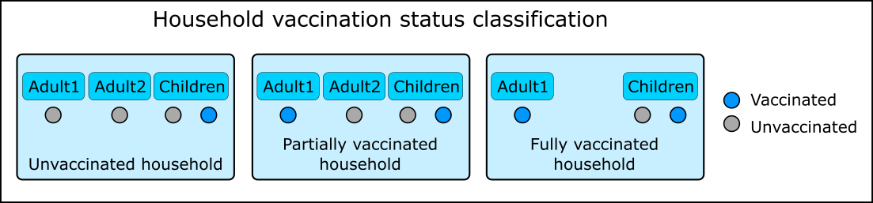

*Figure 1: Classification of household vaccination status is based on adult vaccination only.*

# Exploratory analysis

Check whether the study design is going to work:

* Plot counts per calendar week for children by age group for each event type:
  + Can we see how many children are getting vaccinated early given the eligibility date for their age group?
* Plot weeks between vaccinations.
* Plot timings between positive test and CYP vaccination.
* Plot timings of adult and child dose.
* Cross tab of adult and child vaccination status.
* Counts of each event type:
  + First dose, Second dose, Booster dose
  + Number of COVID-19 infections. Split by pre/post eligibility
  + Death
  + Move out of country
  + Number of CYP hospitalised and median length of stay
* Counts of transitions between events (see next section).

CYP become eligible for vaccination at JCVI approval – unless they are within the 14 days following a positive covid-19 test. After vaccination, individuals become ineligible for 28 days. Eligibility and censoring to be defined as:

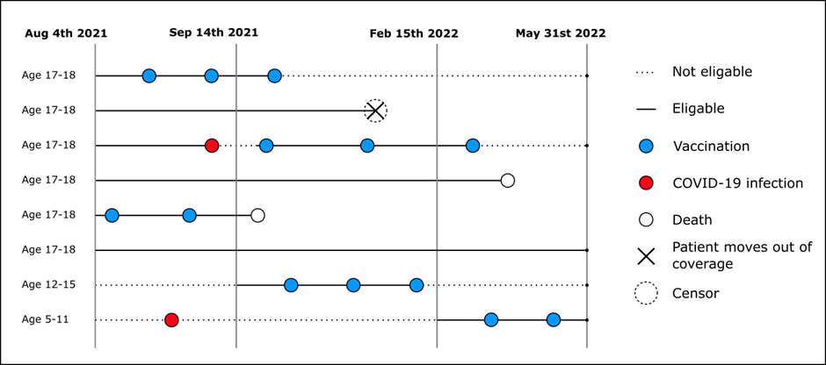

*Figure 2: Eligibility and censoring timelines*

The graphic above can be defined using the following table structure:

*Table 1*

|  |  |  |  |  |  |  |  |  |  |
| --- | --- | --- | --- | --- | --- | --- | --- | --- | --- |
| **id** | **state_from** | **state_to** | **date_from** | **date_to** | **time_from** | **time_to** | **Age_cat** | **futime** | **State_no** |
| 1 | unvacc | infection | 01/01/21 | 16/01/21 | 0 | 15 | 16_17 | 300 | 1 |
| 1 | infection | unvacc | 16/01/21 | 13/02/21 | 15 | 43 | 16_17 | 300 | 2 |
| 1 | unvacc | first_dose | 13/02/21 | 22/03/21 | 43 | 80 | 16_17 | 300 | 1 |
| 1 | First_dose | Second_dose | 22/03/21 | 14/06/21 | 80 | 164 | 16_17 | 300 | 3 |

In the cases where CYP received their vaccine prior to being eligible following an infection (i.e. did not wait the recommended 28 days) the eligibility date is shifted to the date of the vaccine.

**Multistate model for vaccine uptake**

The multistate model analyses the transition of CYP between the 6 states:

1. Unvaccinated
2. Infection
3. 1st COVID-19 vaccination
4. 2nd COVID-19 vaccination
5. 3rd COVID-19 vaccination

CYP can move up the vaccination chain, or into the ineligible/ infected state, however they can only move from the infected state to the vaccination state that they were in prior to infection. The final, 3rd vaccine acts as an absorbing state, and not further information (infection) will be included for analysis beyond this state.

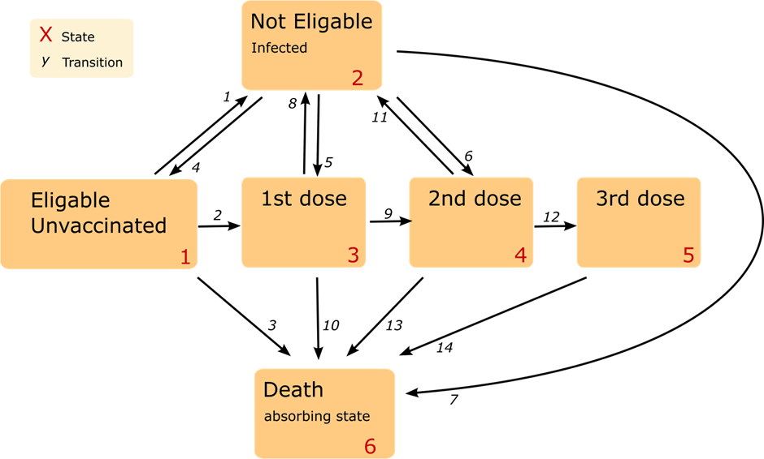

*Figure 3: Multistate model for vaccine uptake*

Wales will provide a script to each nation that can be applied to any data with table 1 format that will perform the analysis.

Reference groups will be key when running the Cox Proportional Hazard models. In particular, the age group reference will be important to identify. We will either need to change the reference group to assess each of the categories or combinations of characteristics (using interaction effects), e.g., age 16-17* high deprivation status.

# Meta-analysis

Results to be shared:

* Sample descriptive table of characteristics (counts, column percentages, rates), stratified by age group and vaccination status.
* Raw model results: log hazard ratios and SEs.

Sample statistics to be combined. Log HRs and SEs to be pooled.

## Sensitivity analysis

* To be completed following initial results being available from nations, discussed and implemented as needed.
  + Children who are hospitalised for 3 or more days during the study period